- Thoracentesis / Chest Tube Placement
  - Review indications, contraindications, & complications
    - Indications
      - Diagnostic for pleural effusion

      - Therapeutic for pneumothorax, hemothorax, pleural effusion
      - Ultrasound allows estimation of the volume, depth and nature of the pleural fluid. Remote marking of a potential aspiration site by the radiology department is less reliable and associated with as many complications as blind intervention.
    - Contraindications
      - Infection overlying the insertion site
      - Severe hemodynamic or respiratory compromise
      - Mechanical ventilation
      - Small/loculated effusion
      - Blood thinners/bleeding disorder (relative)
    - Complications

      - Pain
      - Cough
      - Infection
      - Air embolism
      - Pneumothorax
      - Hemothorax
      - Intra-abdominal organ injury
      - Nerve damage
      - Surgical emphysema
      - Post-expansion pulmonary edema

  - Review anatomy
    - Safe Triangle
1
3
2
- Lateral border of pectoralis major
- Anterior border of latissimus dorsi
- 5th intercostal space
- Inserting a drain in the safe triangle minimizes the risk of disturbing underlying structures such as the internal mammary artery and avoids damage to muscle or breast tissue resulting in scarring. A more posterior position may be chosen if deemed a more suitable site through bedside ultrasound scanning by a competent practitioner.
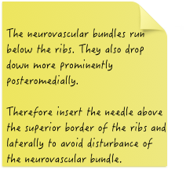
    - Intercostal Spaces
  - Review equipment & transducer choice
    - Transducer
      - Linear, Curvilinear, or Phased to diagnose
      - Linear to perform procedure (MSK, Soft Tissue, or Lung application)
    - Equipment
      - Sterile transducer cover
      - Sterile PPE and drapes if situation allows
      - Antiseptic solution
      - Lidocaine in 5 or 10mL syringe with 25G needle (long enough to reach pleura) or introducer needle (if using Seldinger).
      - Seldinger chest drain kit or equivalent chest tube kit
      - Pigtail catheter or chest tube with trocar
      - Drain tubing and pleurovac
      - Suture (e.g. 1-0 Silk)
      - Sterile gauze and adhesive dressing or tape
  - Demonstrate procedure & reiterate key points
    - Patient position
      - Supine/reclining with arm raised and placed behind patient’s head
Better access to “Triangle of Safety” and in resuscitative situations.
      - Upright/Sitting
Better for drains being inserted for pleural fluid (gravity is your friend).
    - Apply antiseptic and drape patient (if situation allows).
    - Identify anatomic landmarks with ultrasound in longitudinal axis and align end of transducer so intercostal space is midline on the screen.
    - Infiltrate skin with lidocaine at superior or inferior edge of transducer (depending on side of patient and dominant hand preference).
    - Advance needle IN PLANE while injecting lidocaine alternating with pulling back into the intercostal space and visualize it entering the pleura.
    - Upon accessing pleural space, advance needle 0.5-1cm further.
    - Remove syringe and ensure fluid/air coming out of pleural space. Then quickly cover end of needle with thumb.
    - Insert guidewire (with or without US guidance). Ensure at least 10cm of wire remains external to needle.
    - Remove introducer needle over the wire. NEVER LET GO OF THE WIRE!
    - Use scalpel to make a small incision, cutting AWAY from the wire, in an AP direction.
    - Advance dilator over guidewire to level of safety marker, then remove dilator.
    - Advance catheter/drain over guidewire, ensuring the wire protrudes from the distal end of the drain and advance drain over the wire into the pleural space (~10cm depending on patient). Remove guidewire while keeping hold of the drain.
    - Keep thumb over end of drain until connected to suction tubing. Don’t pull the drain out.
    - Suture into place using preferred technique (I like to demonstrate “Chinese handcuff” technique) and apply gauze and adhesive dressing.
  - Assist learners with practice on phantom (try to reuse guidewires as much as possible).

- Pericardiocentesis
  - Review indications, contraindications, & complications
    - Indications
      - Emergent for life-threatening hemodynamic changes in a patient with pericardial effusion
      - Non-emergent for aspiration of pericardial fluid in hemodynamically stable patients for diagnostic, palliative, or prophylactic reasons
    - Contraindications (relative)
      - Blood thinners/bleeding disorders
      - Traumatic (some argue for thoracotomy, instead)
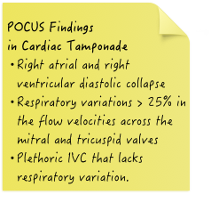
    - Complications
      - Dysrhythmias
      - Coronary artery puncture or aneurysm
      - Left internal mammary artery puncture or aneurysm
      - Hemothorax
      - Pneumothorax
      - Pneumopericardium
      - Hepatic injury
      - False-negative (blood is clotted)
      - False-positive (intracardiac aspiration)
      - Reaccumulation of pericardial fluid
  - Review anatomy
    - Nearby structures
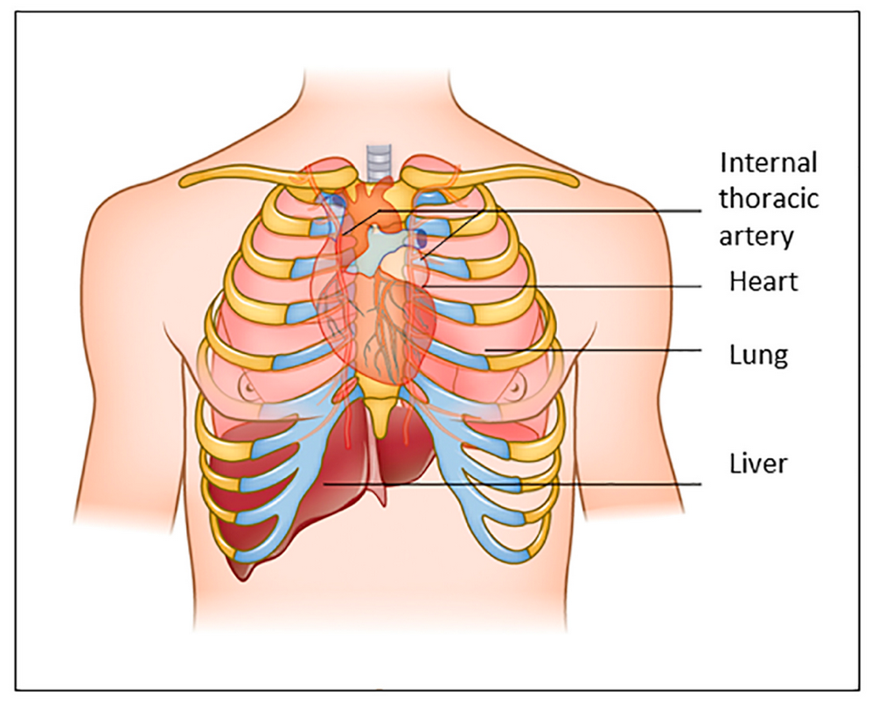

    - Various approaches
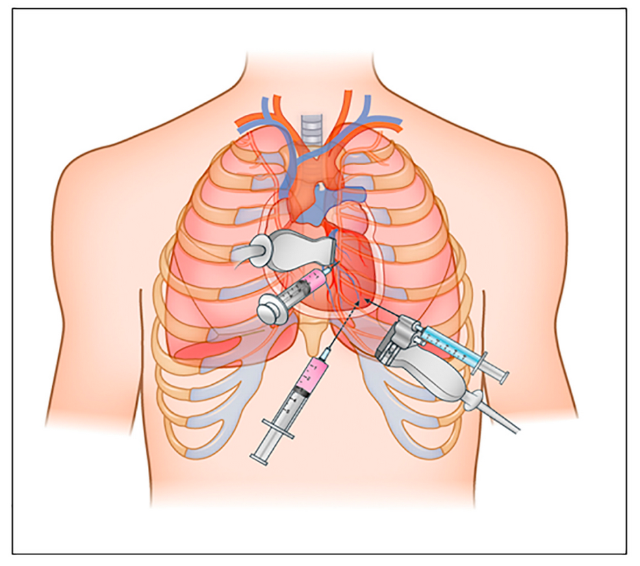
3
2
1

Location | Description | Pros | Cons
Apical  1 | - Insert needle 1-2cm lateral to the apex beat w/in the 5th, 6th, or 7th intercostal space  - Advance needle over the superior border of the rib to avoid intercostal bundle | - Thicker left ventricular wall is more likely to self-seal after puncture  - Avoids encountering lung air with US  - Shortest path to the pericardium | - Risk of ventricular rupture, due to proximity to the LV  - Risk of pneumothorax, due to the proximity to the left pleural space
Parasternal  2 | - Insert needle into the 5th intercostal space, close to the sternal margin  - Advance the needle perpendicular to the skin (at the level of the cardiac notch of the left lung) | - Phased array allows for good visualization of structures intracostally | - Risk of pneumothorax & puncture of the internal thoracic vessels (if the needle is inserted more than 1cm laterally)
Subxiphoid  3 | - Insert needle between the xiphoid process and left costal margin  - Once below the cartilage cage, lower the needle to a 15 to 30 degree angle with the abdominal wall directed towards the left shoulder | - Lower risk of pneumothorax | - A steeper angle may enter the peritoneal cavity & a medial direction increases the risk of right atrial puncture  - Left liver lobe may be transversed intentionally, if alternate site is not available  - Longer path to reach the fluid

  - Review equipment & transducer choice
    - Transducer: phased (or curvilinear for subxiphoid)
    - Equipment
      - Sterile transducer cover
      - Antiseptic and sterile PPE (if situation allows)
      - Lidocaine with 25G needle and 5-10cc syringe
      - Long needle of choice (spinal, IV catheter, from kit)
      - 3 way stopcock
      - Large syringe (20mL+)
      - Guidewire or 6Fr or 8Fr pigtail catheter (optional)
  - Demonstrate procedure & reiterate key points
    - Patient position: reclining (maximizes fluid drainage) or supine
    - Choose site that is most easily obtained and where the most amount of fluid is present and closest to the surface
    - Apply antiseptic and drape patient (if situation allows)
    - Infiltrate dermis with lidocaine and advance into subcutaneous and deeper tissues
    - Connect stopcock to syringe and to spinal needle
    - May consider making a small incision in the skin to decrease resistance (optional)
    - Insert needle towards the pericardial space under US guidance as directed in above chart, while applying negative pressure until fluid is aspirated in the syringe (or ECG monitor shows ST elevation)
    - When bloody fluid is obtained, may inject agitated saline using stopcock to confirm position within the pericardial sac
    - Once fluid is drained, may either remove the needle or continue with the Seldinger technique and place a catheter. (Catheter may stay in place for 24 hours).
  - Assist learners with practice on phantom

- Lumbar Puncture
  - Review indications, contraindications, & complications
    - Indications
      - CSF sampling for diagnosis of CNS infection, malignancy, guillain-barre
      - CSF removal (hydrocephalus, pseudotumor cerebri)
      - Intracranial pressure (ICP) evaluation
      - Treatment for ALL
    - Contraindications
      - Evidence of increased ICP such as 3rd or 6th nerve palsy with decreased level of consciousness OR Cushing’s triad or obtundation (may be able to perform LP after imaging)
      - Shock, or respiratory distress where positioning would compromise the patient
      - Local skin infections over proposed puncture site (absolute contraindication)
      - Spinal column deformities (relative if using US)
      - Uncontrolled bleeding diathesis
    - Complications
      - Bleeding
      - Infection
      - Herniation (not if you checked ONSD before )
      - Hematoma at site of puncture with spinal cord impingement
      - Nerve injury
      - Post-LP Headache
      - Spinal fluid leak (ultimately requires blood patch)
  - Review anatomy
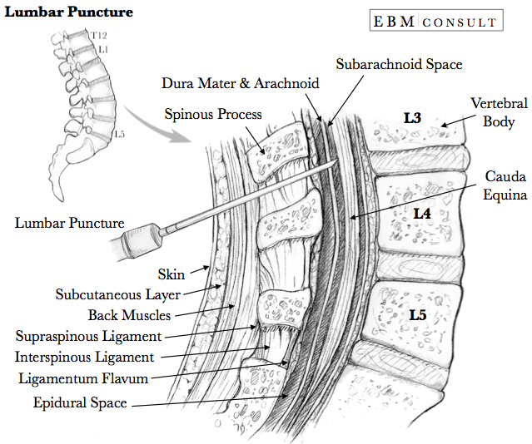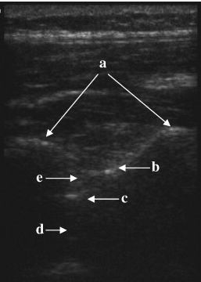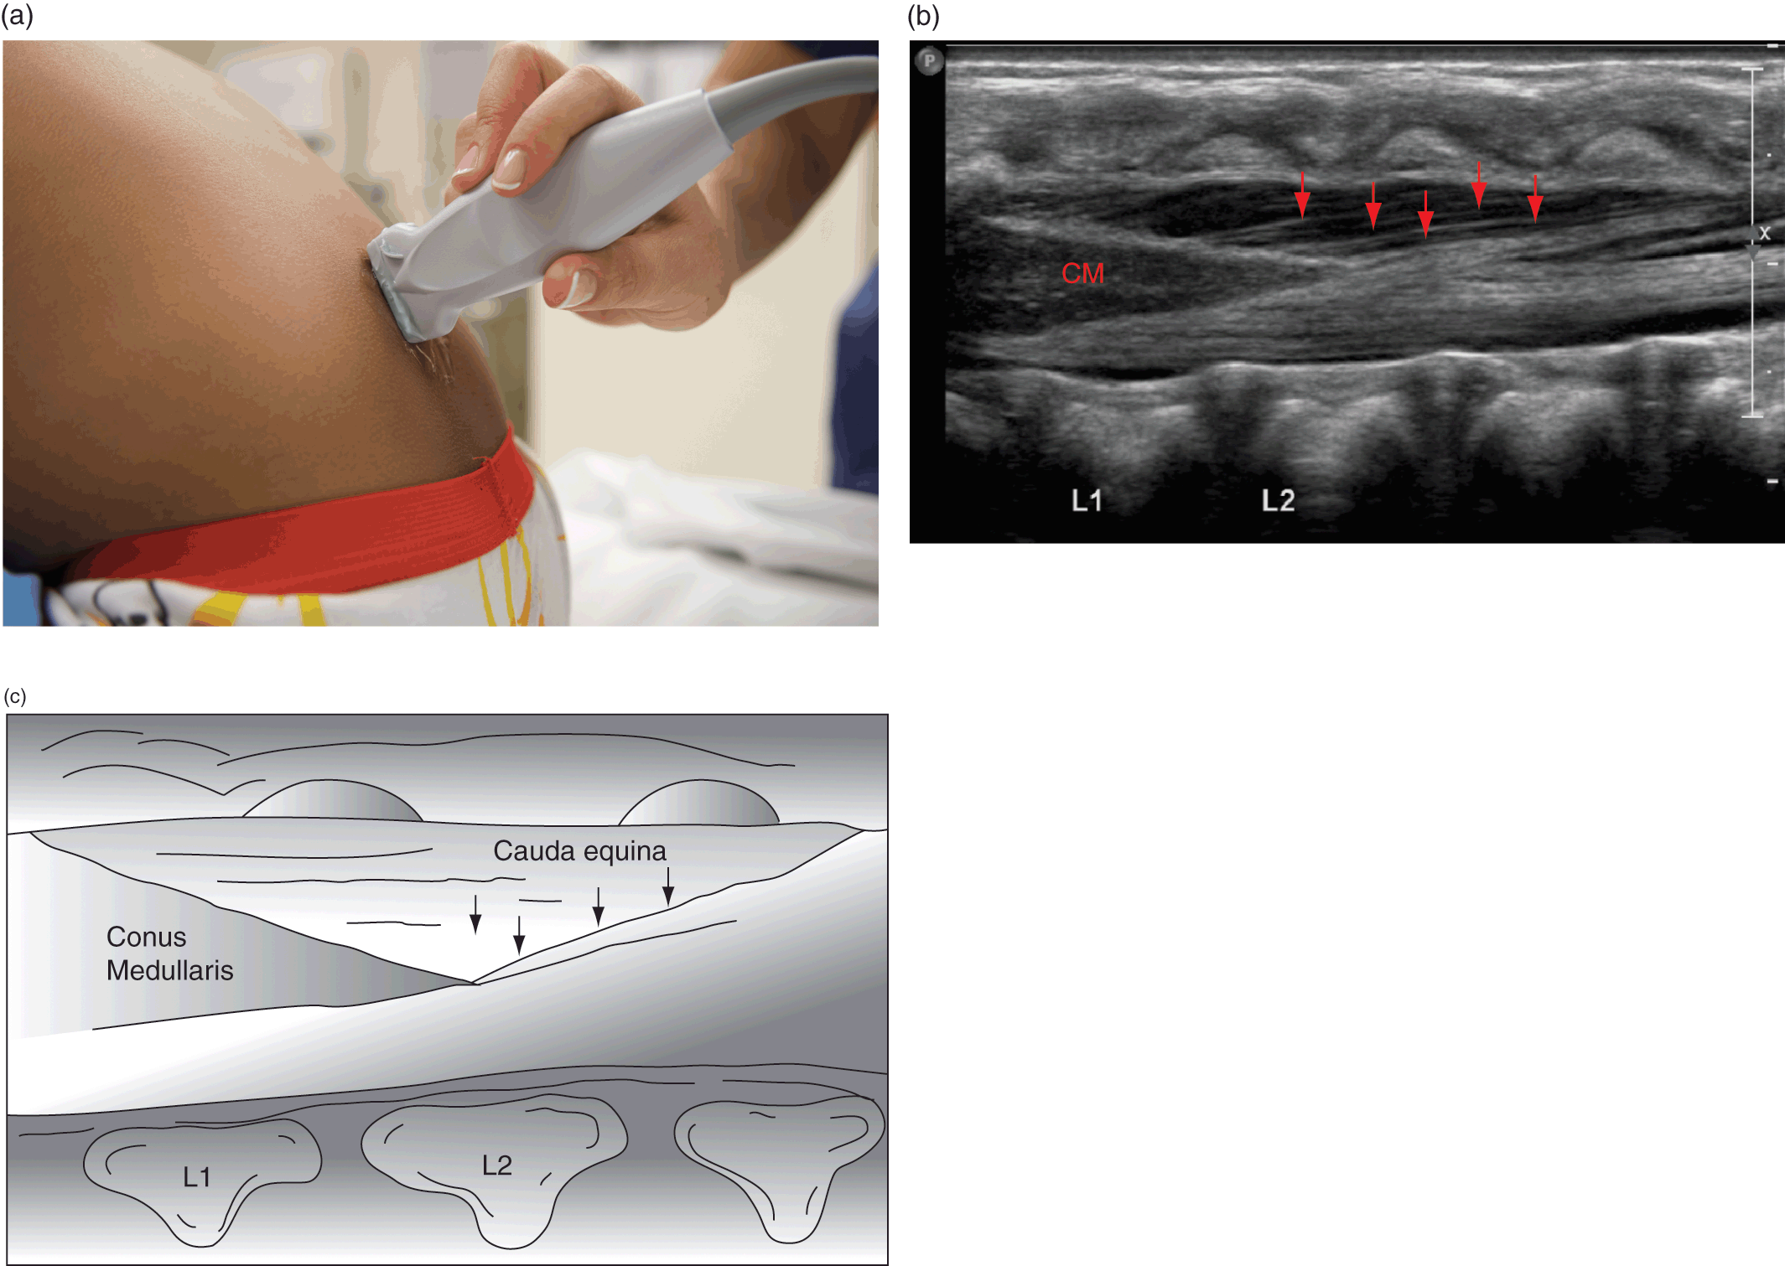
- Laminae
- Ligament flavum
- Dura mater
- Subarachnoid space
- Epidural space

  - Review equipment & transducer choice
    - Transducer
      - Linear if landmarks are somewhat palpable
      - Curved or phased if landmarks are too deep to palpate
    - Spinal needle with a stylet (A 22-gauge needle is preferred)
      - 1.5 inch – infants
      - 2.5 inch – children
      - 3.5 inch – adults/adolescents
      - 4.5 inch in patients who are significantly obese
    - Skin-cleansing agents
    - Local anesthetic (Lidocaine)
    - Drapes and sterile transducer cover
    - Collection tubes
    - Manometer (if needed typically in other kit)
  - Demonstrate procedure & reiterate key points
    - Position patient in lateral decub or sitting position. Drape and prep as usual.
    - Place sterile cover over the transducer.
    - Application set to MSK
    - Probe marker directed cephalad, scan along the median to identify conus (if possible) down to the sacrum.
    - Identify the intraspinous space with the most amount of fluid (below the conus).
    - For an In-Plane view, align the caudal spinous process on the screen so it is just out of view. (That way, when you insert your needle, it will not hit the bone).
    - Place your needle at the end of the probe opposite the probe marker and insert at about a 30-45 degree angle so as to avoid the caudal spinous process.
    - Once the needle is clearly visible, redirect the needle deeper to that it avoids hitting the cranial spinous process.
    - Continue to follow the needle until it penetrates the ligamentum flavum and into the anechoic spinal fluid in the subarachnoid space.
    - Proceed as usual with the remainder of the procedure.
  - Assist learners with practice on phantom

- Soft Tissue / Foreign Body
  - Review indications, contraindications, & complications
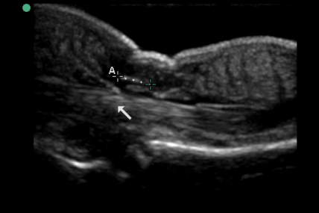
    - Indications
      - Detection of radiolucent foreign bodies
      - Assistance and verification of foreign body removal
    - Contraindications
      - Objects in close proximity to vessels or tendons
    - Complications

      - Increased tissue injury
      - Infection
      - Wound healing problems
      - Retained FB
      - Failure to recognize normal anatomical structures

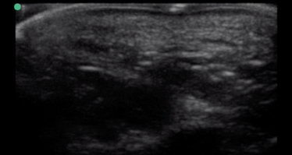
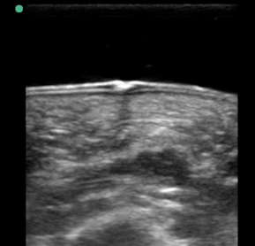
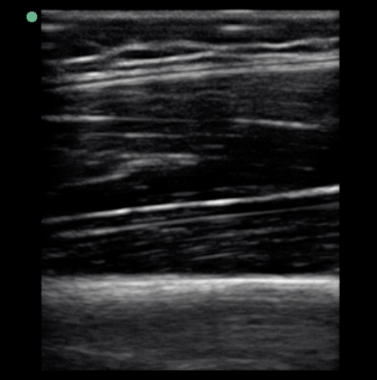
  - Review anatomy
- Dermis/Epidermis
- Adipose/SQ tissue
- Fascia
- Muscle
- Fascia
- Muscle
- Bone

  - Review equipment & transducer choice
    - Transducer
      - Linear for objects <6cm deep
Without standoff pad
      - Curved for objects >6m deep
With standoff pad
    - Standoff pad, glove filled with water, or saline bag (with air removed)
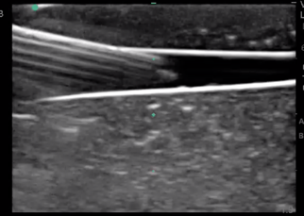
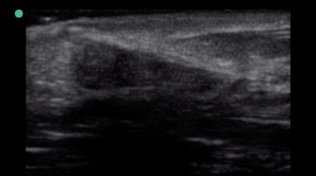
    - Skin marker
    - Scalpel and suture kit
    - Water bath
  - Demonstrate procedure & reiterate key points
Wood
    - Sonographic appearance
Metal
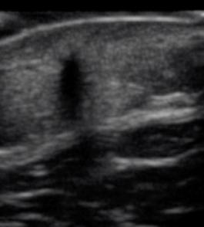
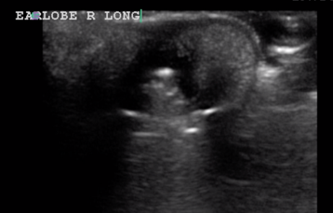
      - Wood or plastic
          - hyperechoic
          - shadowing
      - Metal or glass
          - Reverberation
Smooth
          - Comet tail artifact
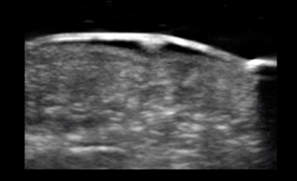
      - Smooth or flat surface
          - Dirty shadowing
Irregular
          - Reverberation artifact
      - Irregular surface
          - Clean shadowing
Edema
      - Present for more than 24 hrs
          - Surrounding hypoechoic rim (from soft tissue edema)
    - Longitudinal
    - Transverse
    - Measure it
    - Put some color on it
    - Anesthetize and repeat (lidocaine will displace FB)
    - Mark in long and TRV axes with skin marker at most superficial point. Connect the dots.
  - Assist learners with practice on phantom

